Product category: AC DRIVES (VFD’s)

AC DRIVE COMPANY

MITSUBISHI

1. Model name: MITSUBISHI FR-A SERIES

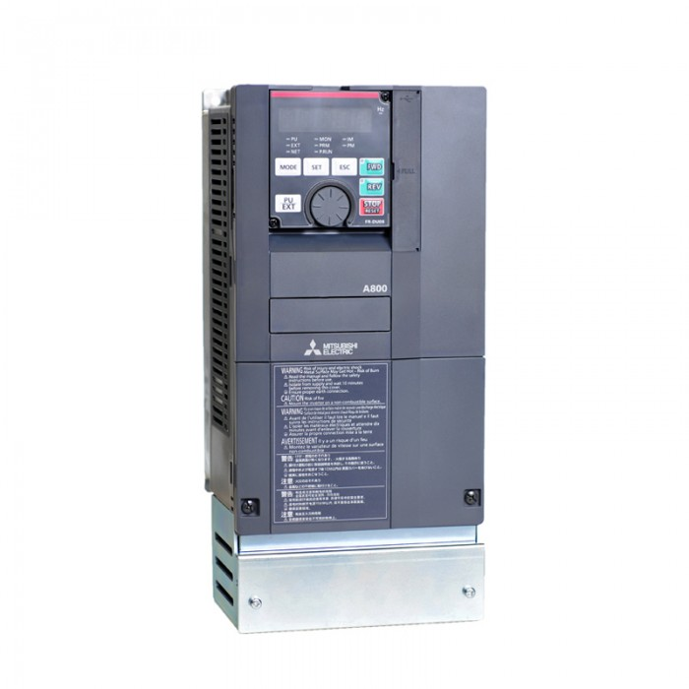

1. **MODEL NAME : MITSUBISHI FR-A800 PLUS SERIES**

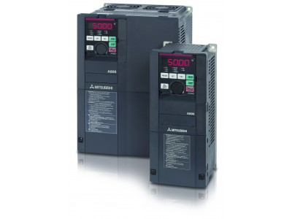

1. MODEL NAME: MITSUBISHI FR-F SERIES

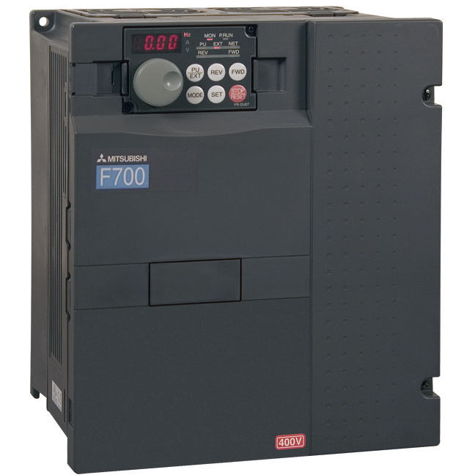

1. MODEL NAME: MITSUBISHI FR-D SERIES

[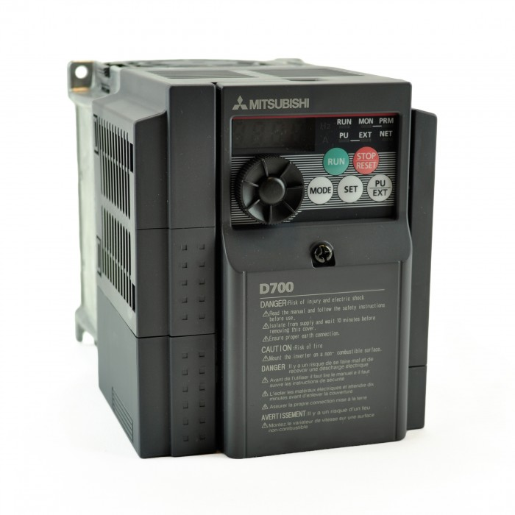](https://www.deltaelectronicsindia.com/industrial-automation/touch-panel-hmi-human-machine-interfaces/tp70p/" \o "TP70P)

1. MODEL NAME: MITSUBISHI FR-E SERIES

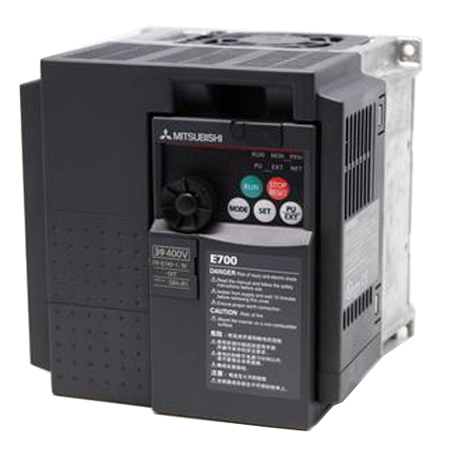

1. MODEL NAME: MITSUBISHI FR-CS SERIES

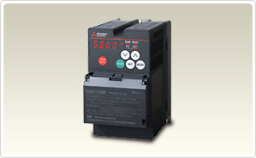

1. MODEL NAME: ALL OTHER MITSUBISHI DRIVES

